Smart AI Powered Vision Glasses for Assisting Visually Impaired Individuals

Ananya Singh
School of Electronics Engineering
Kalinga Institute Of Industrial Technology(KIIT)
Bhubaneshwar,Odissa
2330288@kiit.ac.in
Utkarsh Raj
School of Electronics Engineering
Kalinga Institute of Industrial Technology(KIIT)
Bhubaneshwar,Odissa
2330416@kiit.ac.in
Pranjali Sinha
School of Electronics Engineering
Kalinga Institute of Industrial Technology(KIIT)
Bhubaneshwar,Odissa
2330288@kiit.ac.in
Tejashwini Kar
Assistant Professor,School of Electronics Engineering
Kalinga Institute of Industrial Technology(KIIT)
Bhubaneshwar,Odissa
tkarfet@kiit.ac.in
Yash Panhale
School of Electronics Engineering
Kalinga Institute of Industrial Technology(KIIT)
Bhubaneshwar,Odissa
2330418@kiit.ac.in

Abstract—The Smart AI Powered Vision Glasses is a wearable assistive system designed to help visually impaired individuals navigate their surroundings. The system integrates computer vision and embedded systems to provide real-time object detection and obstacle awareness. A Raspberry Pi 3B+ with a Pi Camera Module v2 captures live video, and the YOLOv4-Tiny algorithm is implemented using OpenCV for object detection. Detected objects are converted into audio feedback using an offline text-to-speech system. Ultrasonic sensors interfaced with an ATmega328 microcontroller detect nearby obstacles and provide directional vibration feedback. The system operates offline, making it suitable for real-world environments. Experimental results demonstrate reliable object detection and timely feedback, improving user safety and independence.
Keywords—Assistive Technology, Computer Vision, YOLO, Raspberry Pi, Embedded Systems

Introduction
Technology has improved quality of life significantly, yet visually impaired individuals still face challenges in navigation and object recognition. Traditional aids like white canes detect obstacles but cannot identify objects or provide contextual understanding.

This work proposes a wearable assistive system integrating computer vision and embedded systems to provide real-time object detection and obstacle awareness. The system enhances environmental understanding through audio and tactile feedback, enabling safer and more independent navigation.

Motivation
Visually impaired individuals face challenges in navigating their surroundings independently. Traditional aids such as white canes provide limited information and cannot identify objects. This project aims to develop a smart assistive system that enhances environmental awareness through real-time object detection and obstacle sensing.

Background Studies/Literature Survey
Existing systems use ultrasonic sensors for obstacle detection but lack object recognition. Recent advancements in deep learning, particularly YOLO-based algorithms, enable real-time object detection. Integration with text-to-speech systems allows conversion of visual data into audio feedback. However, many solutions lack portability and offline capability.

Objectives
- Develop a wearable assistive system
- Implement real-time object detection
- Detect obstacles using sensors
- Provide audio and vibration feedback
- Ensure offline operation
- Optimize portability and usability

Methedology.

Applied Techniques and Tools
The system uses YOLOv4-Tiny for object detection and OpenCV for image processing. The Raspberry Pi Camera Module captures video input. Ultrasonic sensors detect obstacles, and eSpeak provides audio output. Python and Embedded C are used for implementation.

Technical Specifications
Hardware includes Raspberry Pi 3B+, Pi Camera, ATmega328 microcontroller, ultrasonic sensors, vibration motors, and power supply. Software includes Python, OpenCV, NumPy, and YOLOv4-Tiny. The system is designed for real-time processing and offline operation.

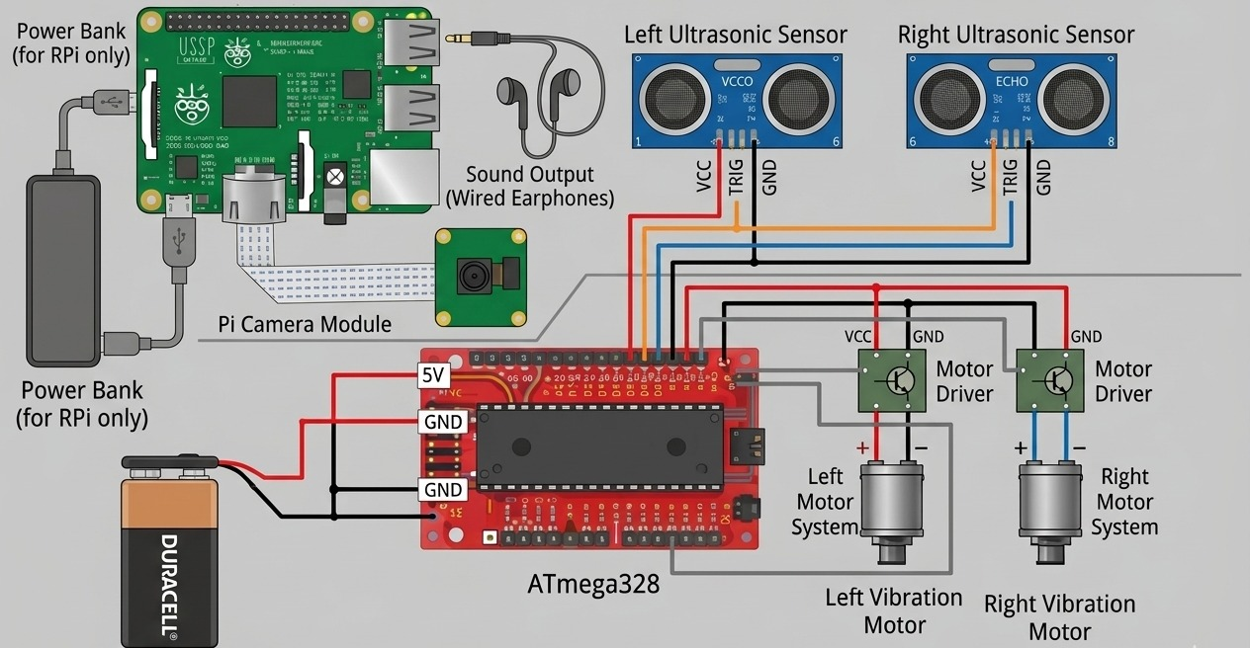
Fig. 1: Circuit diagram of the system

Design Approach
The system consists of two processing units: Raspberry Pi for object detection and ATmega328 for sensor processing. Camera input is processed for object detection, and results are converted into audio output. Ultrasonic sensors detect obstacles and trigger vibration feedback. Both processes run simultaneously for real-time performance.
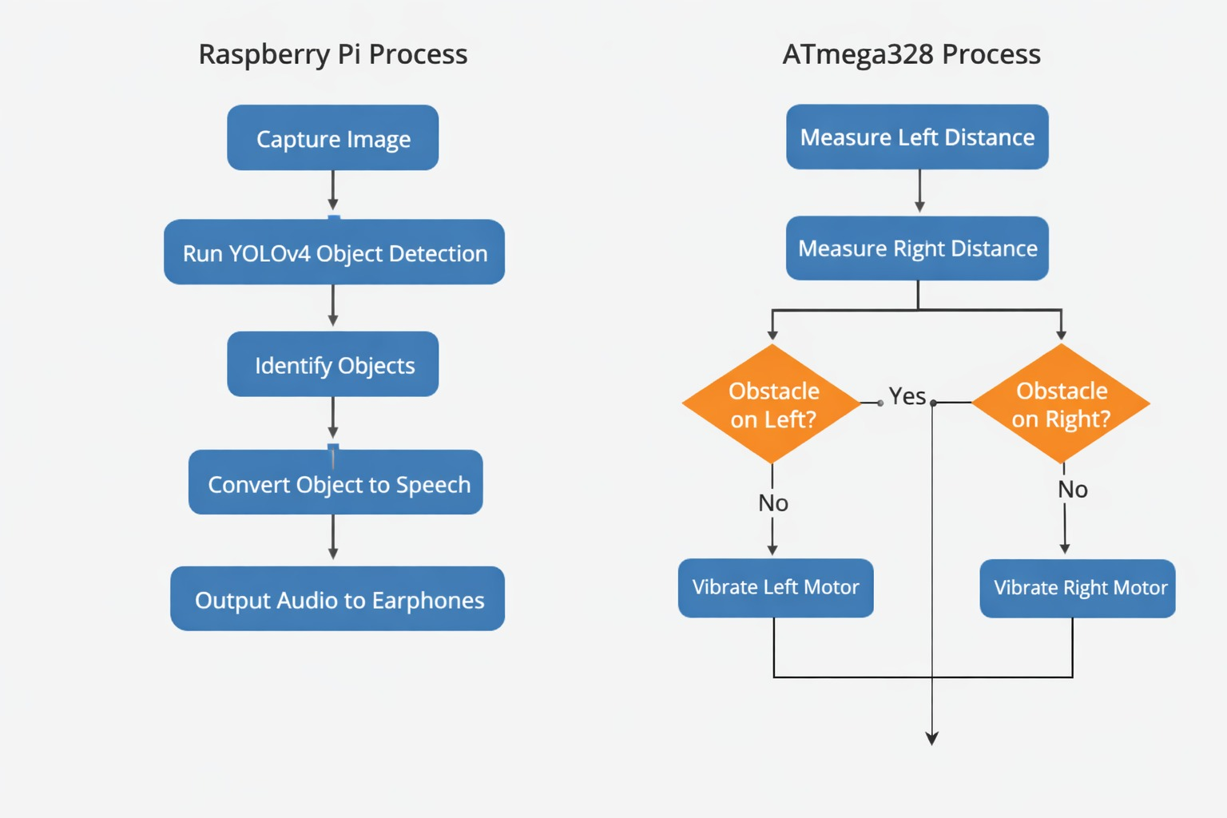
Fig. 2: Flowchart of the proposed system

EXPERIMENTATION AND TEST

Mathematical Modelling, Circuits etc.

The system uses basic mathematical modelling for obstacle detection using ultrasonic sensors. The distance is calculated using the time taken by the ultrasonic wave to travel to the object and return:

Distance = (Speed of Sound × Time) / 2

The system consists of two main circuit sections. The first section includes ultrasonic sensors connected to the ATmega328 microcontroller, which calculates distance and activates vibration motors based on obstacle position. The second section includes the Raspberry Pi connected to the camera module, which performs object detection and provides audio output. A portable power supply ensures stable operation of all components.

Experimental Setup / Design
The system is implemented as a wearable glasses-based prototype. The camera is mounted at the center to capture the user’s view, while ultrasonic sensors are placed at the front to detect obstacles.
The Raspberry Pi processes video input and performs object detection using YOLOv4-Tiny, while the microcontroller handles sensor data and controls vibration motors. Audio feedback is provided through earphones.
Both object detection and obstacle sensing operate simultaneously, ensuring real-time assistance.

Prototype Testing / Simulations

The prototype was tested under different conditions to evaluate performance.
- Objects like people and chairs were detected accurately
- Multiple objects could be identified with slight delay
- Ultrasonic sensors correctly detected obstacles and activated vibration motors
- System worked in real time with both modules running together.
Some limitations were observed, such as reduced accuracy in low-light conditions and minor heating during continuous operation. Overall, the system performed reliably as an assistive prototype.

CHALLENGES, CONSTRAINTS AND STANDARDS
- Challenges and Remedy
The system faced challenges such as weight distribution, wiring complexity, overheating, and audio interference. These were addressed by optimizing component placement, improving wiring, and reducing processing load.

- Design Constraints
Key constraints include limited processing capability of the Raspberry Pi, power consumption, component size, and the requirement for offline operation.

- Alternatives and Trade-offs
A lightweight model (YOLOv4-Tiny) was chosen over more complex models to ensure real-time performance. Offline processing was preferred over cloud-based solutions. Vibration feedback was added to improve usability despite increased hardware complexity

- Standards
The system uses standard technologies such as Raspberry Pi OS, OpenCV, YOLO, and standard audio interfaces. It follows common practices in embedded systems and computer vision.

RESULT ANALYSIS AND DISCUSSION
- Result Obtained
The system successfully detected common objects and provided correct directional feedback through vibration motors. Performance was slightly affected in low-light conditions.

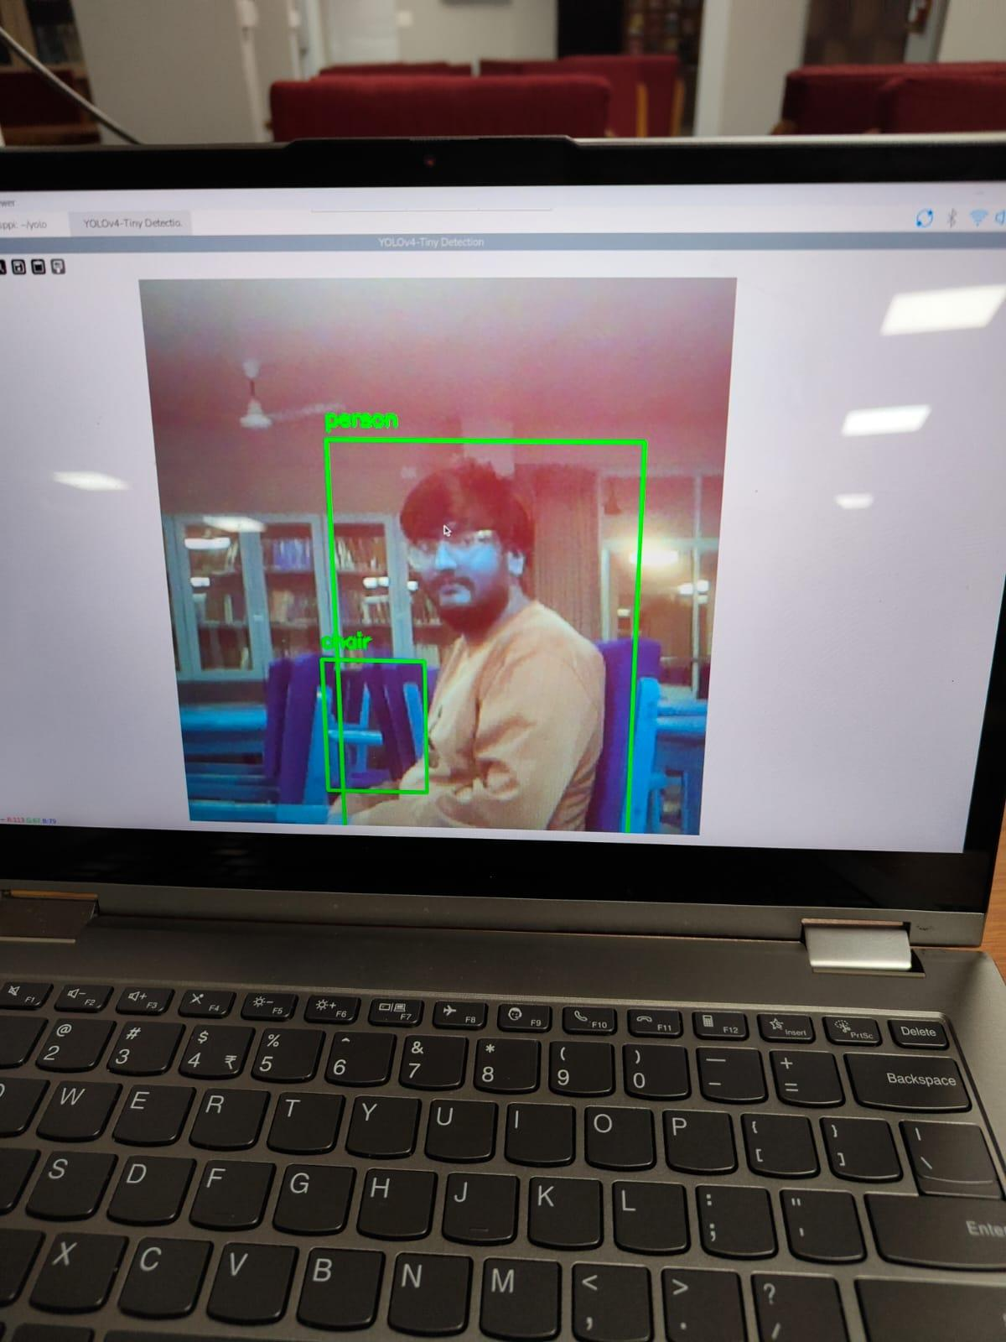
Fig. 3: Object detection output using YOLO

- Analysis and Discussion
The system effectively combines object detection and obstacle sensing to assist users. While performance is satisfactory, improvements are needed in processing speed and environmental adaptability.

- Project Demonstration
The prototype demonstrated real-time object detection and obstacle feedback through audio and vibration, confirming its practical usability.

CONCLUSIVE REMARKS
- Project Planning, Progress and Management

The project followed a structured approach:

- Literature survey and requirement analysis
- Hardware and software selection
- Module-wise implementation
- Integration and testing
- Debugging and optimization

Team coordination ensured timely completion of the project.

- Conclusion
The Smart AI Powered Vision Glasses successfully demonstrate the use of AI and embedded systems in assistive technology. The system enhances navigation and environmental awareness for visually impaired users through real-time object detection and obstacle sensing..

- Future Scope

- Improved ergonomic design
- Use of advanced hardware and AI accelerators
- Integration of GPS and navigation systems
- Addition of text recognition and voice commands
- Better power management and thermal control.

References
- Joseph Redmon et al.,
“You Only Look Once: Unified, Real-Time Object Detection,” IEEE CVPR, pp. 779–788, 2016.

- Alexey Bochkovskiy et al.,
“YOLOv4: Optimal Speed and Accuracy of Object Detection,” arXiv:2004.10934, 2020.

- Gary Bradski,
“The OpenCV Library,” Dr. Dobb's Journal, 2000.

- Raspberry Pi Foundation,
“Raspberry Pi 3 Model B+ Datasheet,” [Online].

- Raspberry Pi Foundation,
“Picamera2 Documentation,” [Online].

- Richard Szeliski,
Computer Vision: Algorithms and Applications, Springer, 2010.
- K. Nakamura et al.,
“Assistive System for Visually Impaired People Using Object Recognition,” IJERT, 2016.

- HC-SR04 Ultrasonic Sensor Datasheet,[Online].

- GNU Project,
“eSpeak Text-to-Speech Synthesizer,” [Online].

